1. Write a mapreduce program to find out number of males and females died in the titanic tragedy and save the output in KeyValue Output format.

Driver:

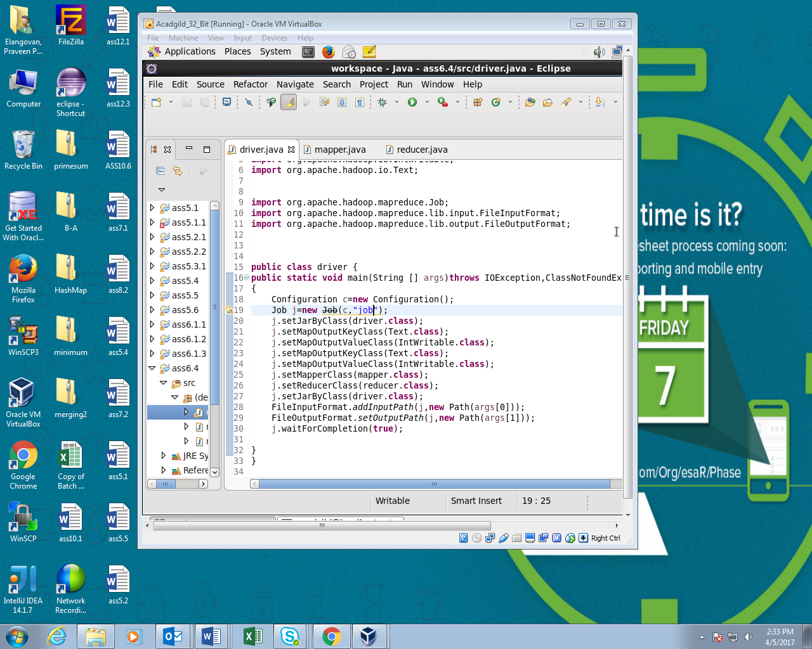

Mapper:

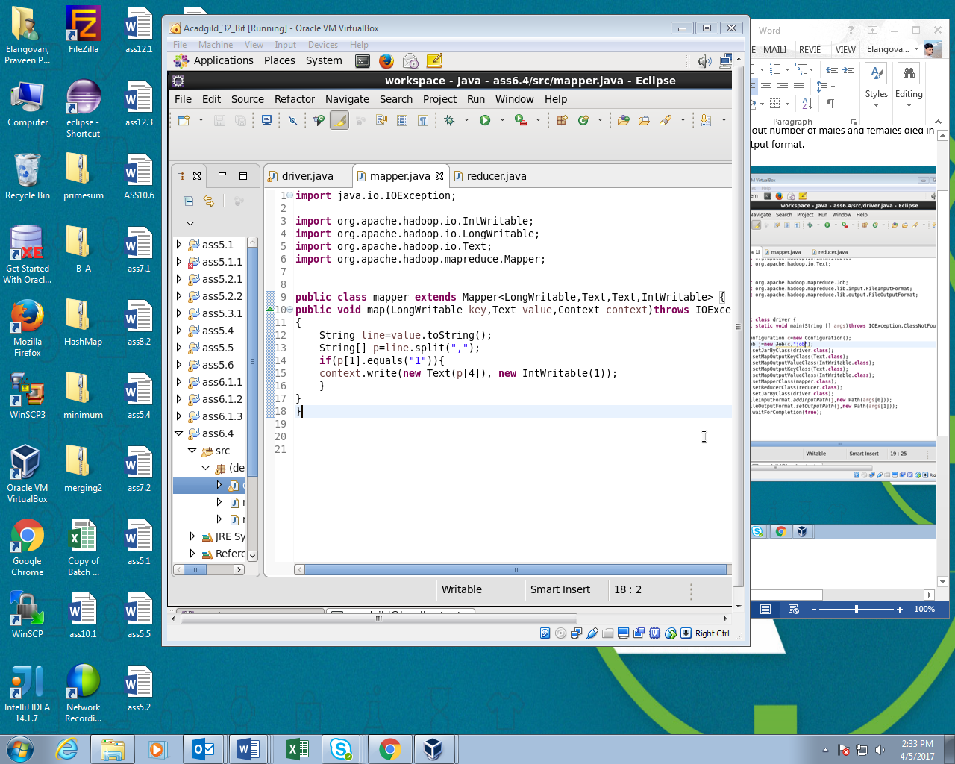

Reducer:

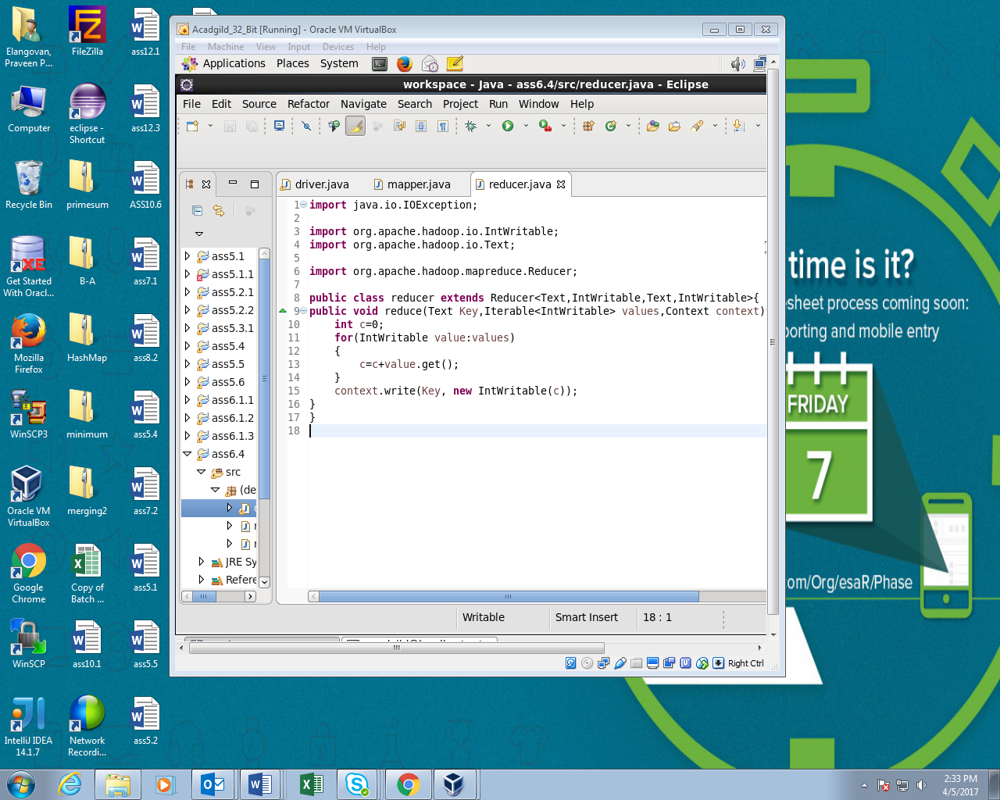

Running JAR file:

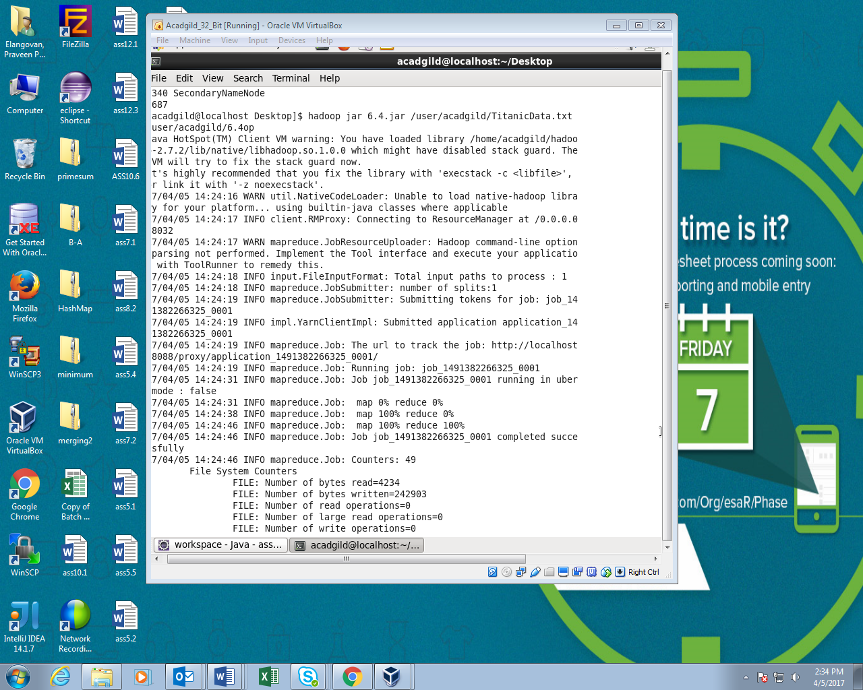

Output:

